Mississippi River Buffer Creation Tutorial

This is a step by step walkthrough of how to create a buffer on the protected side of the levee for the Mississippi River region.

1. 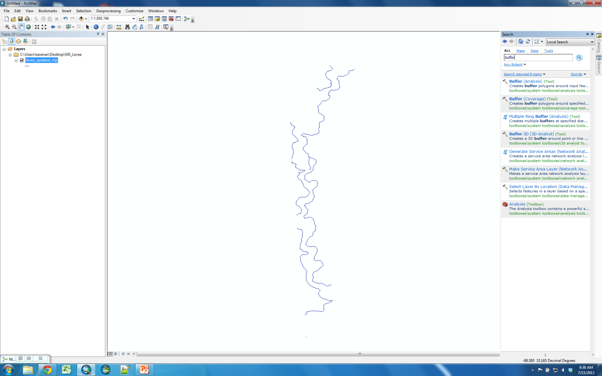First load the original levee line shapefile in ArcMap by clicking the Add Data button (highlighted below) and navigating to the desired file. Click the Search tab on the right-hand side and search for the buffer tool. Click on Buffer (Spatial Analyst).
2. 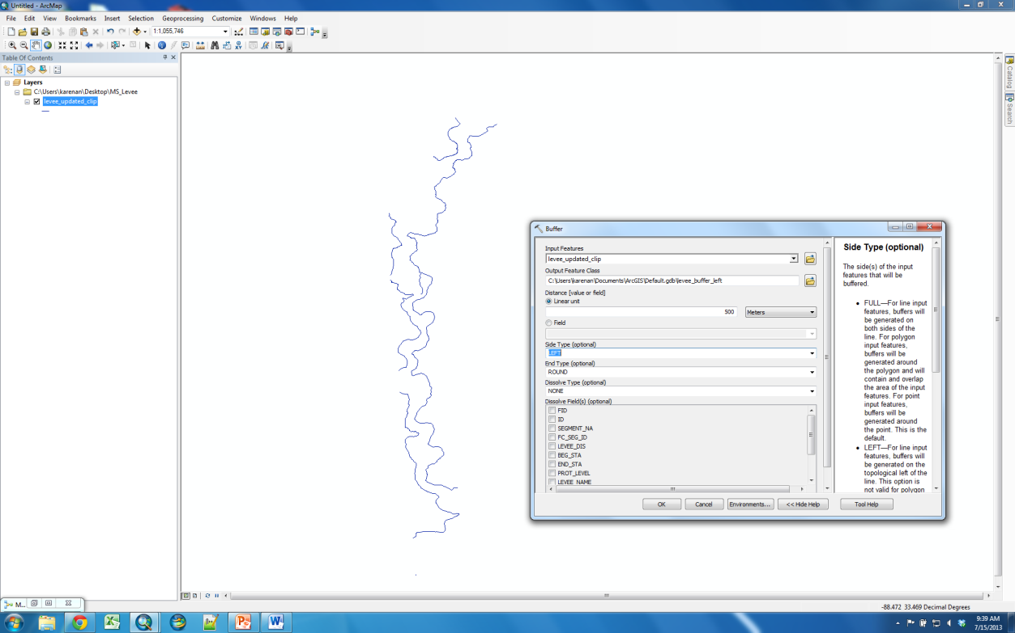The Buffer tool will now ask for the required user inputs. For Input Features, select the original levee line shapefile. The distance input is specified by the user (200 meters can be used as a default value). A buffer has to be created for both the left and right side, so for the Side Type first select either. Go back to the Output Feature Class line and rename your output file to easily identify it as left or right (e.g. “levee_buffer_left”). Click OK. Then repeat the process for the other side.
3. Once both buffers have been made for the left and right side, change their polygon colors to more easily discern between the two. Then, add a basemap by clicking the small down arrow next to the Add Data button and selecting an Imagery basemap. Your window should look similar to the image below:

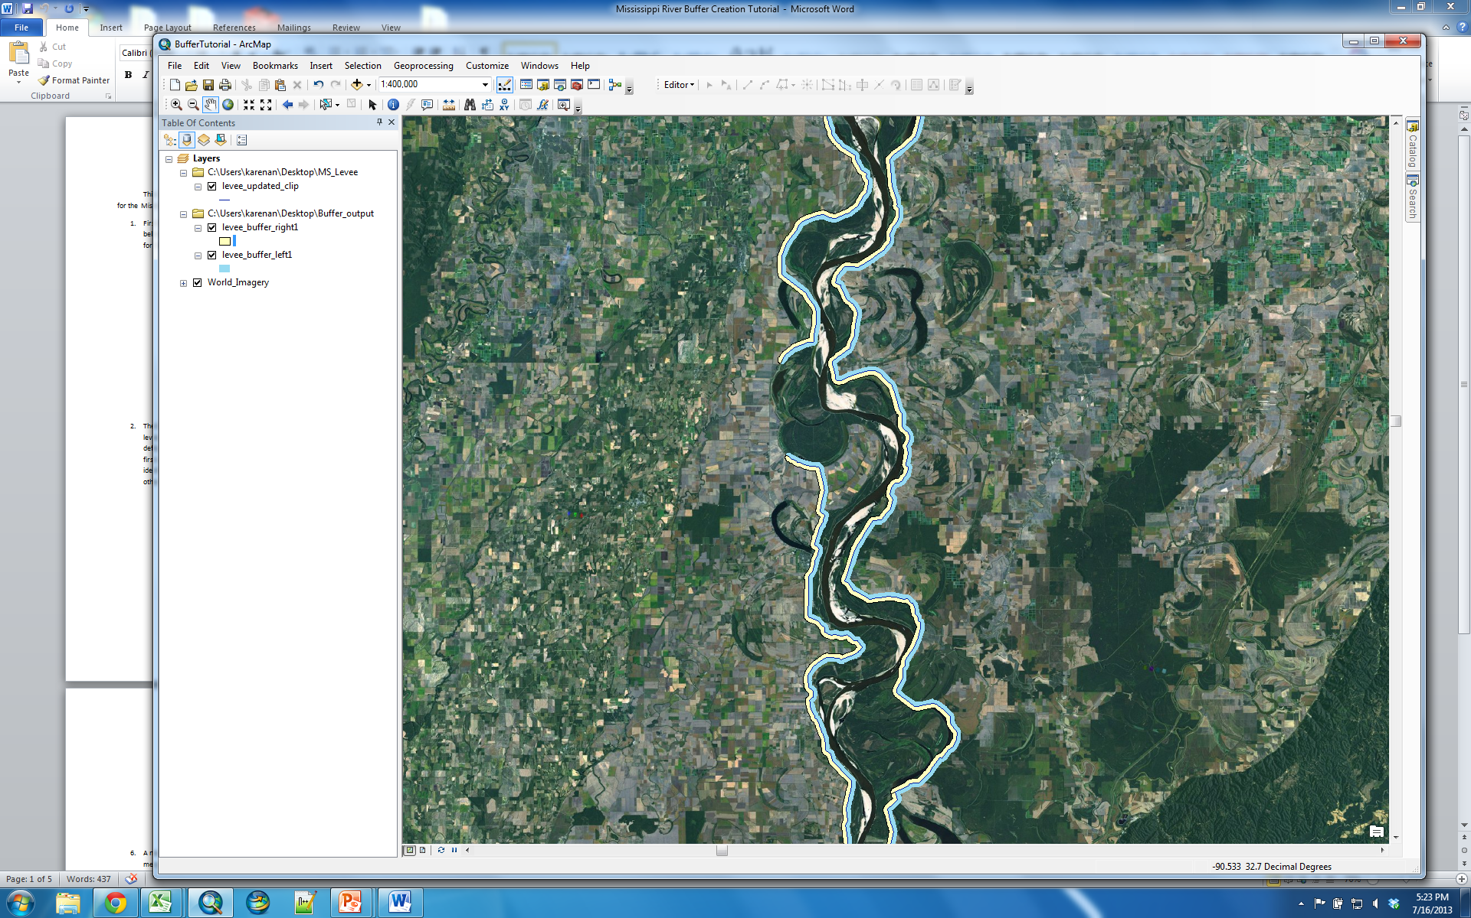

1. Since we are only interested in locating seeps on the protected side of the levee, we will have to manually remove the buffers on the water side. To do this, select Customize > Toolbars > Editor. In the toolbar that appears, click Editor > Start Editing. Choose either the left or right buffer when prompted. Click Continue if any spatial reference warnings appear. Start clicking areas of the levee that are not of interest (on the water side) and right-click to select Delete. Repeat for the second buffer. The end result should look similar to the picture on the right.

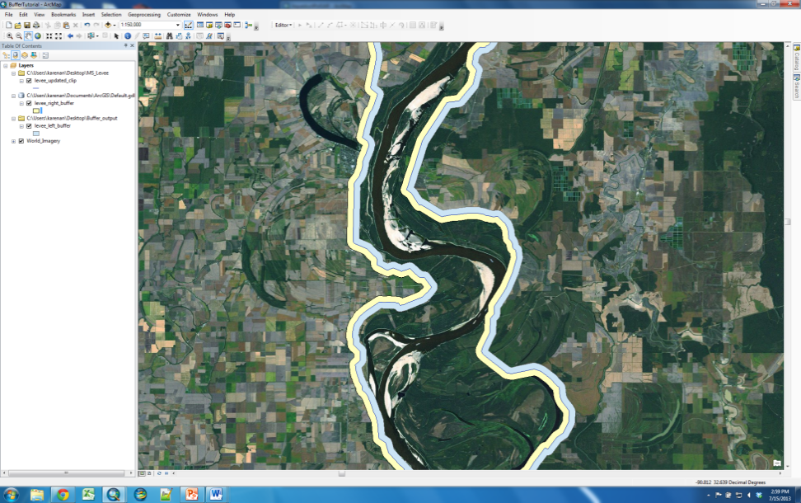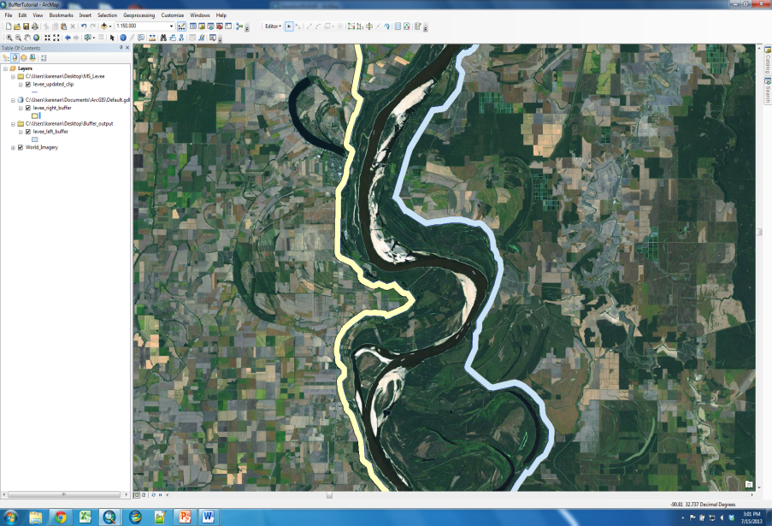

1. After all unwanted buffers have been removed, the left and right buffers can be merged into one buffer shapefile. In the Editor toolbar, select Editor > Stop Editing and save your edits. In the Search tab on the right-hand side of the main window, search for “merge”. Add both the left and right buffers as the Input Datasets. You may specify the output location. Click OK.

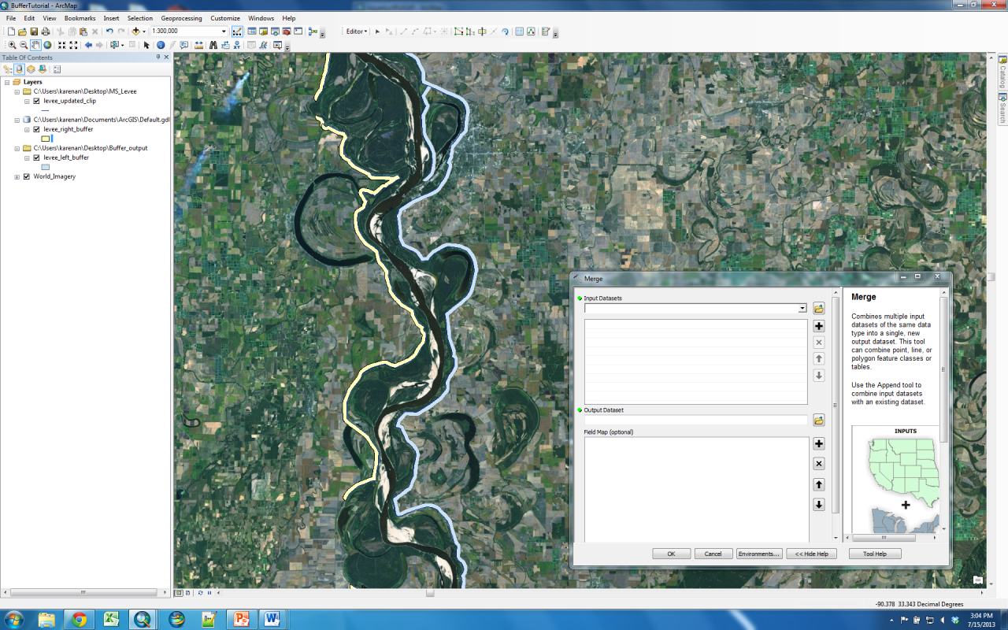

1. A new layer should appear that has combined your edited left and right buffers. To export this merged buffer as a shapefile. Search for “shapefile” and select the Feature Class to Shapefile tool. Select the newly merged buffer as the input feature, specify the output location, and click OK.

